FORK 1 USUARIO GITHUB: https://github.com/Cristiancastillof

REPOSITORIO:
https://github.com/Cristiancastillof/proyectofinalm1
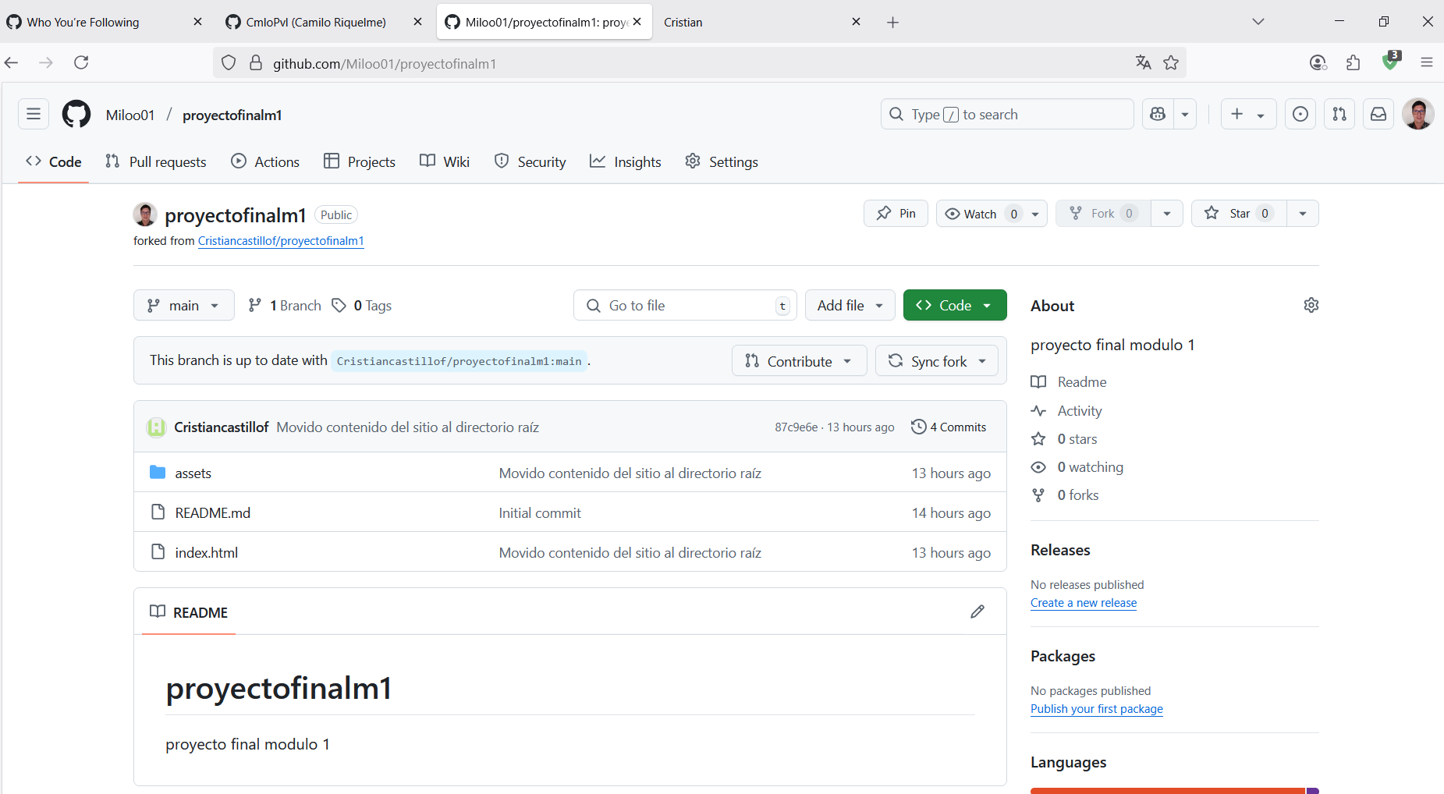

COMMIT -M 1

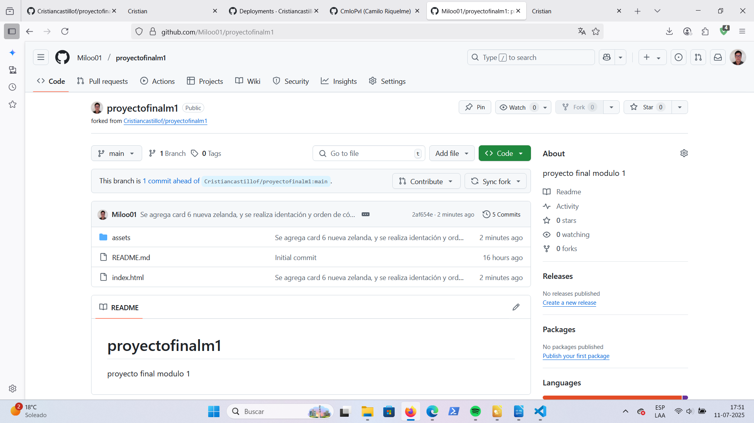

PULL REQUEST 1:

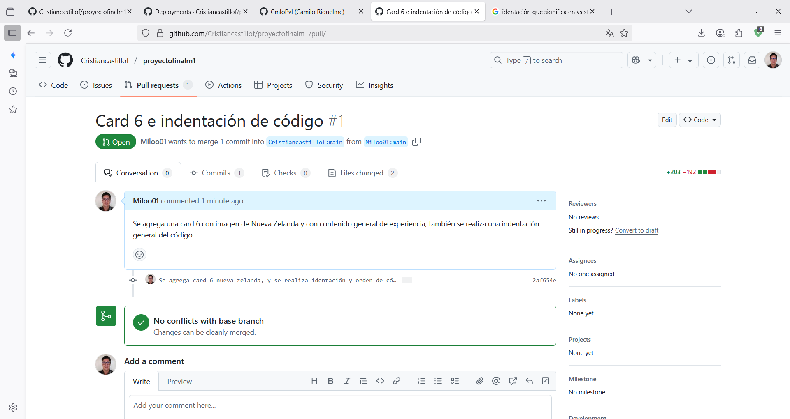

MERGE TO MAIN 1:

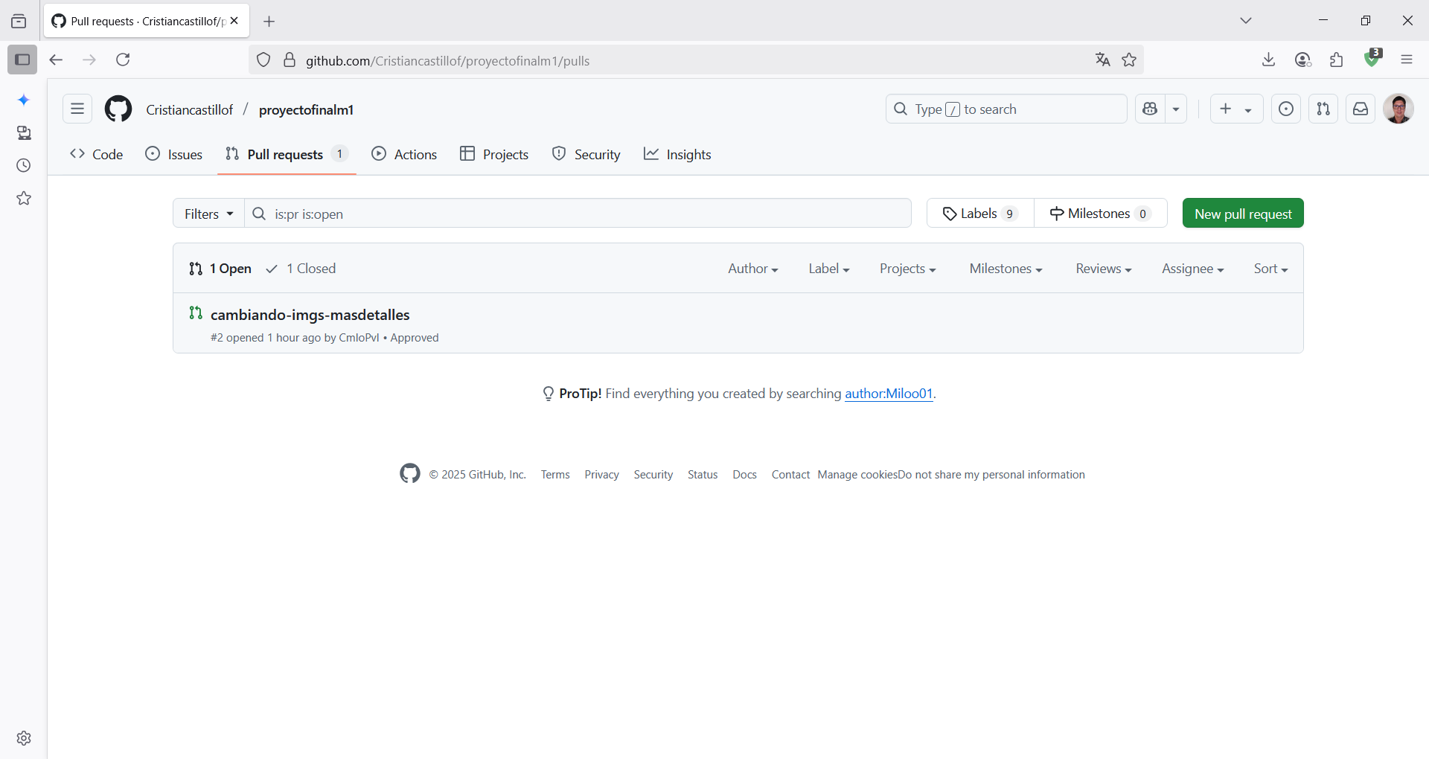

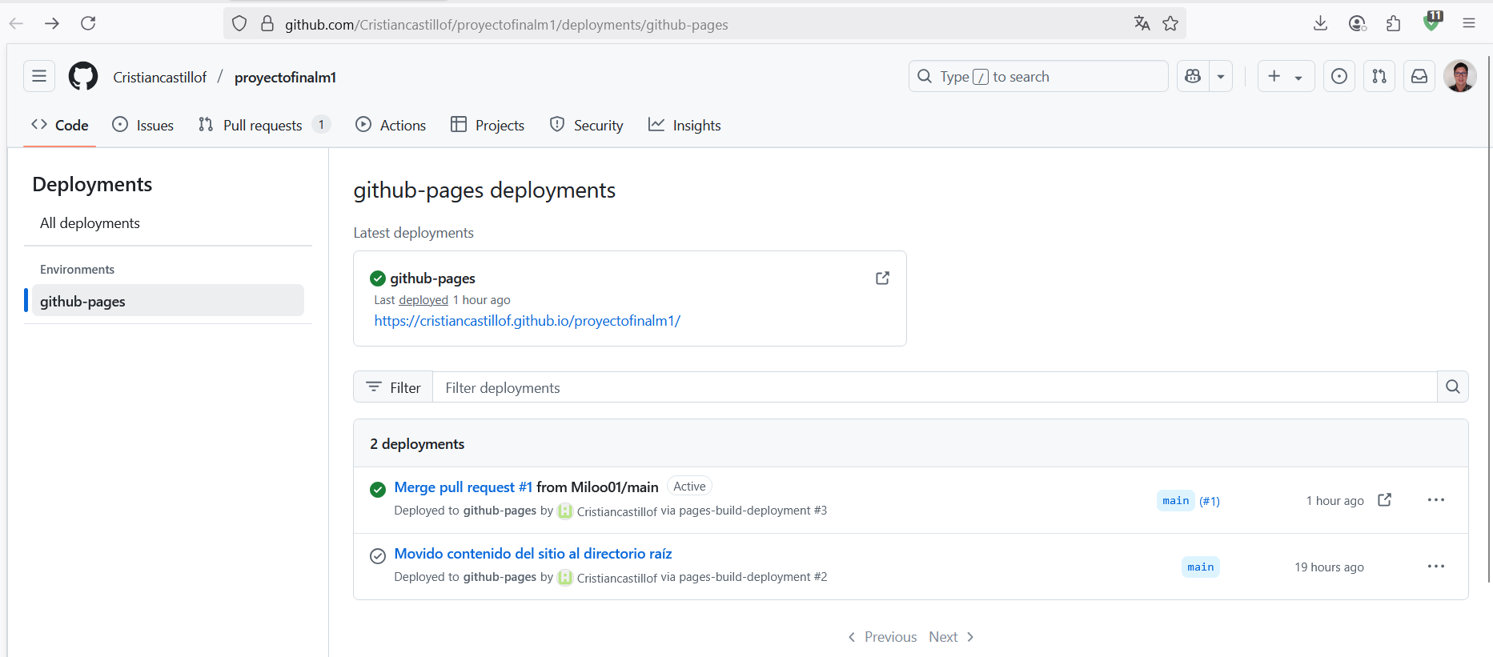

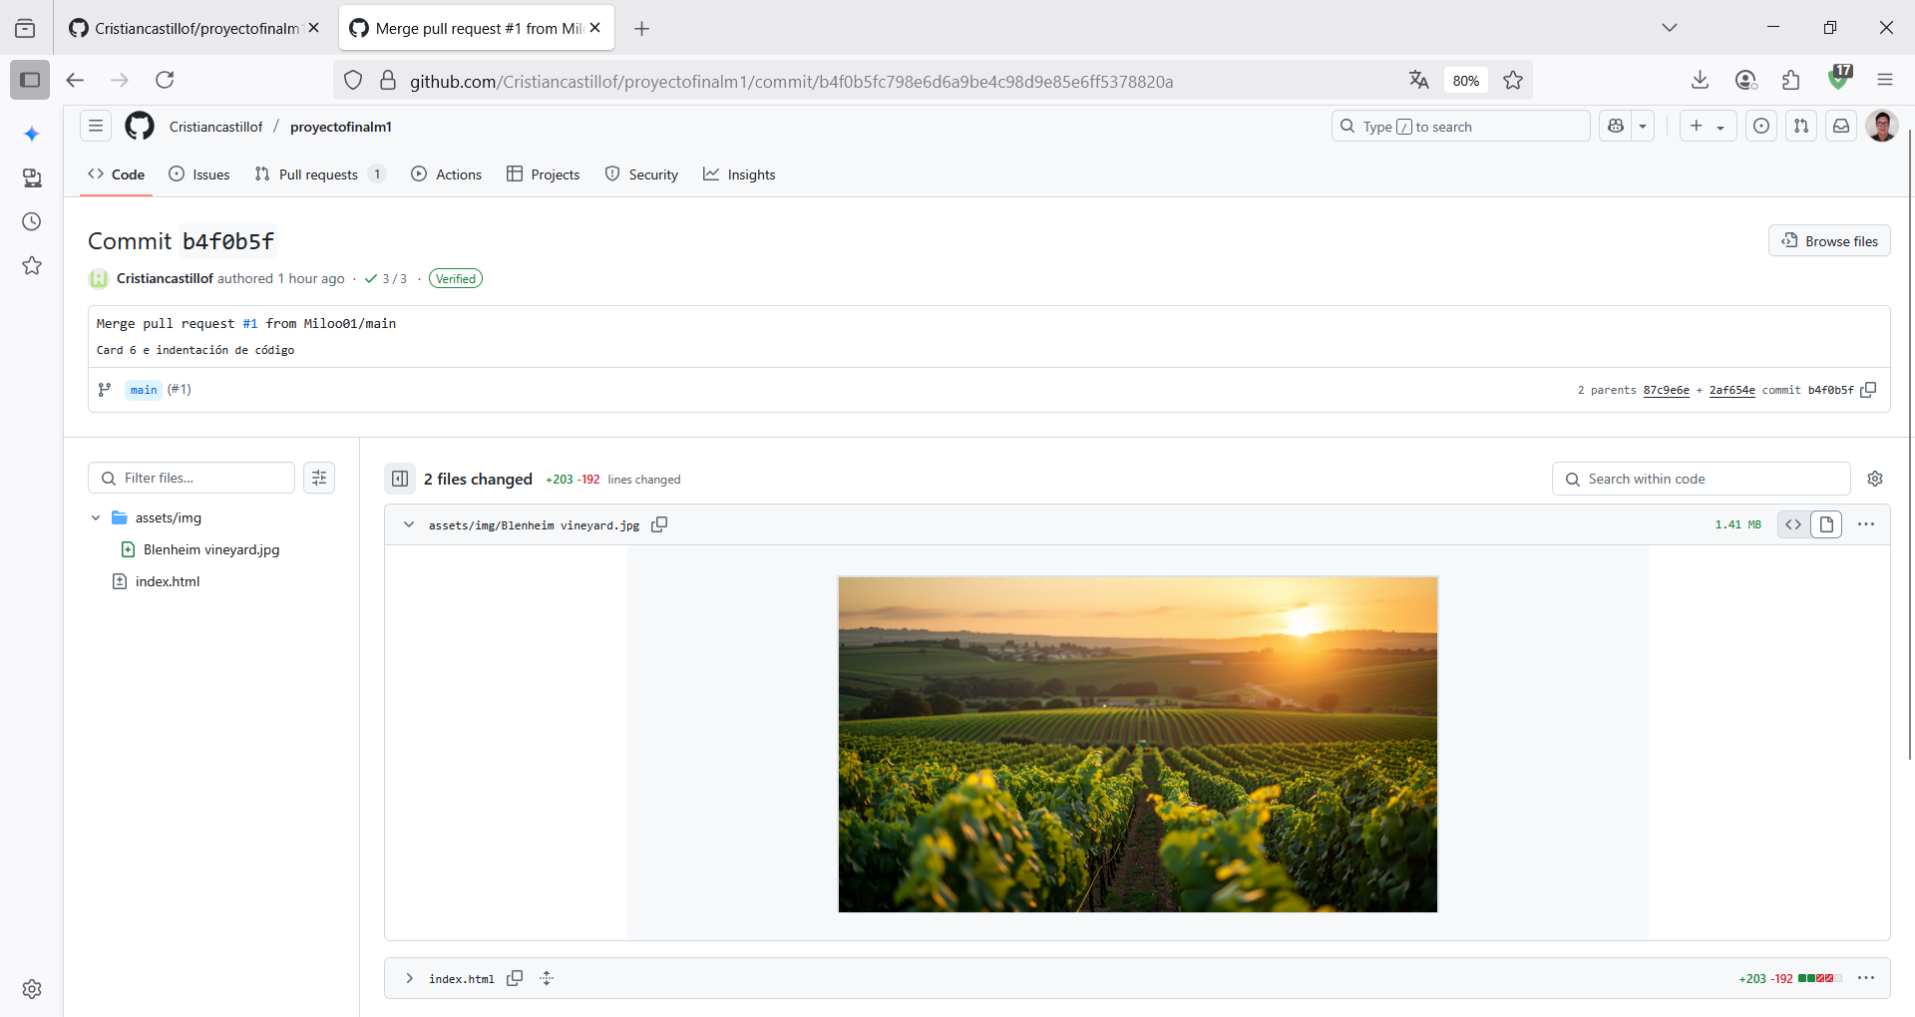

LINK TO PAGE:
https://cristiancastillof.github.io/proyectofinalm1/

FORK 2 USUARIO GITHUB: https://github.com/rodrigovasquezalarcon

REPOSITORIO:
https://github.com/rodrigovasquezalarcon/rodrigovasquezalarcon.github.io

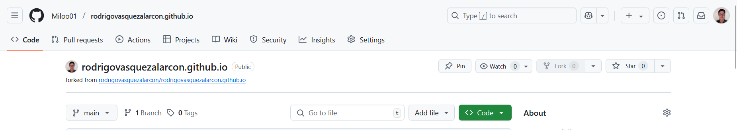

COMMIT -M 2:

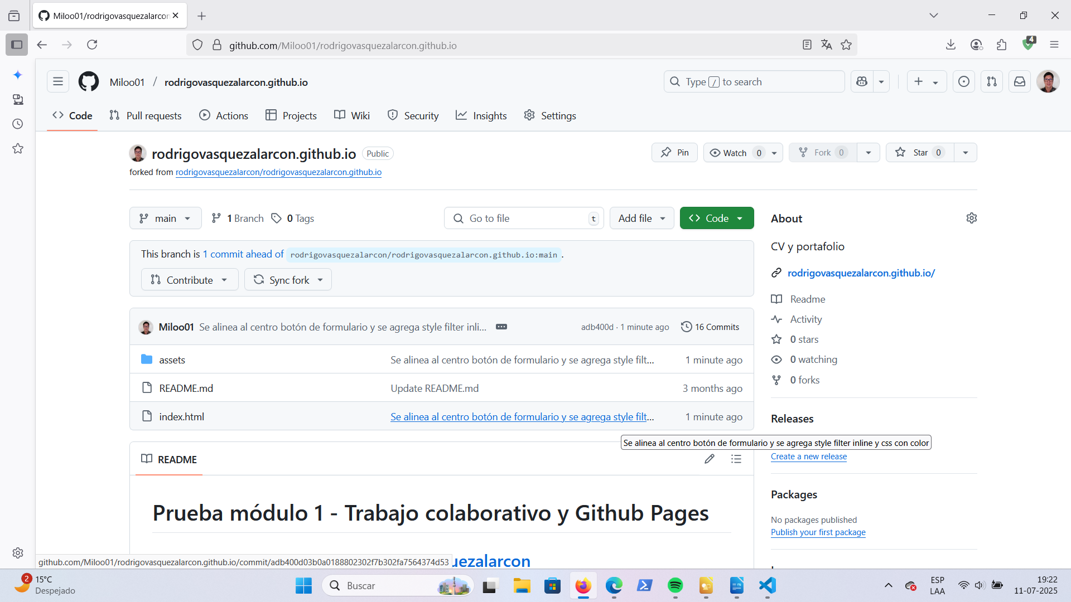

PULL REQUEST 2:

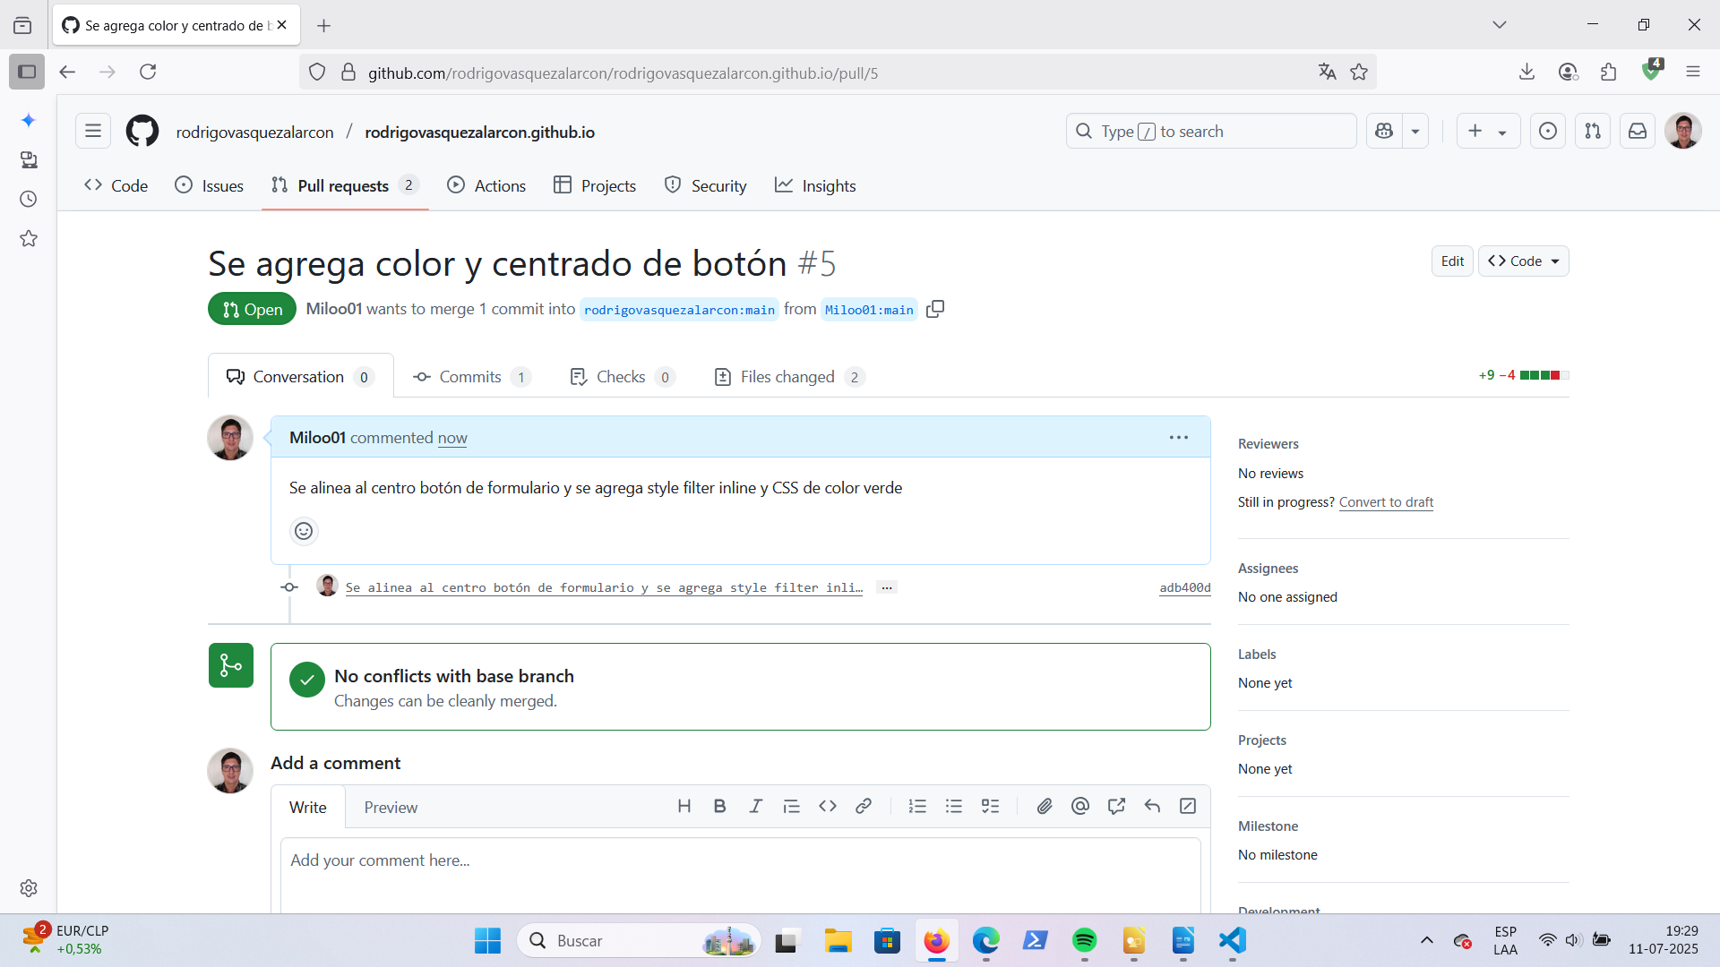

MERGE TO MAIN 2:

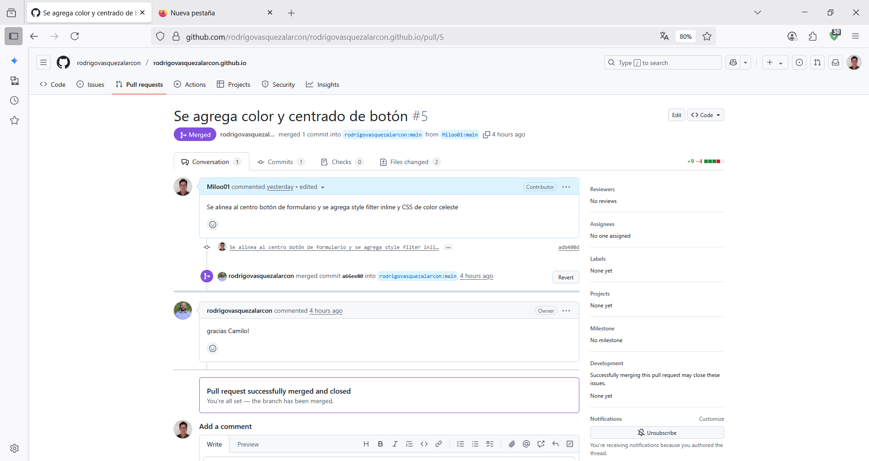
r

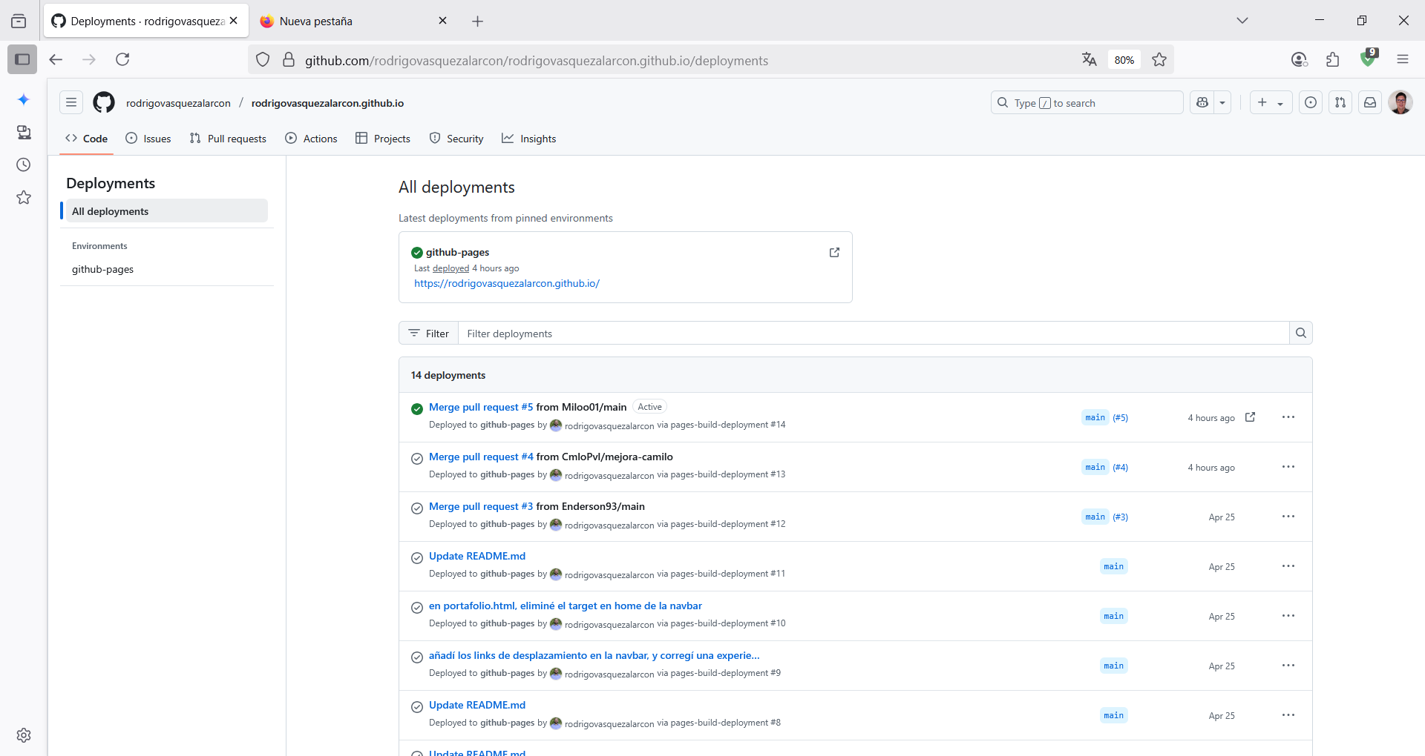

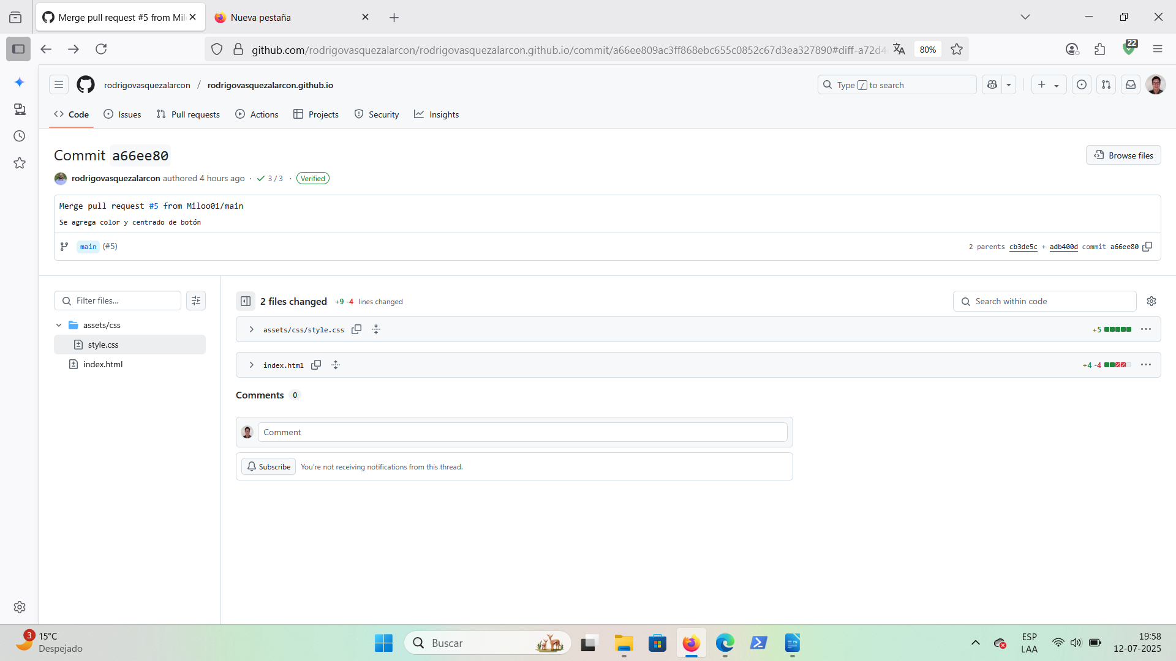

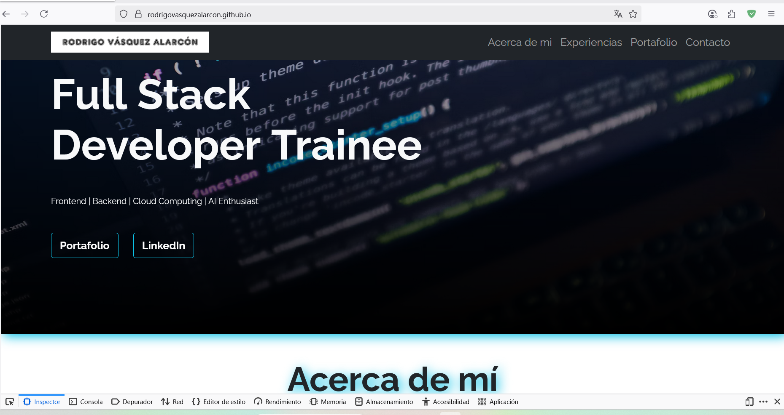
LINK TO PAGE:
https://rodrigovasquezalarcon.github.io/index.html

